For this lab we will examine sexual dimorphism in our species, as represented in this class. Body size is an important ecological variable, and sexual dimorphism therein is associated with particular behaviors and social systems in non-human primates. Here we will see how sex-related variation in our class compares with other populations, and also revisit the brain size data we collected in Lab 1.

After you record your data, turn in your data sheet to me. Be sure to use your 2-digit anonymous identifier and not your name! After your data are submitted, discuss in a small group the questions on page 3 of this handout. We will then review and analyze our data as a class, as in Lab 1.

For the third lab report, answer the questions at the end of this handout. Your answers should be based on the data we review in class (which will be posted to Moodle). Be sure to answer all questions completely! These must be completed on your own (not with a partner), and must be submitted to Moodle no later than 29 October.

Instructions
Measure your height (cm), weight (kg), and digit lengths (cm) as instructed below, and record in the small datasheet. Be sure to remove extra jackets, heavy things in pockets, and other materials that will increase your recorded mass. But please keep your clothes on!

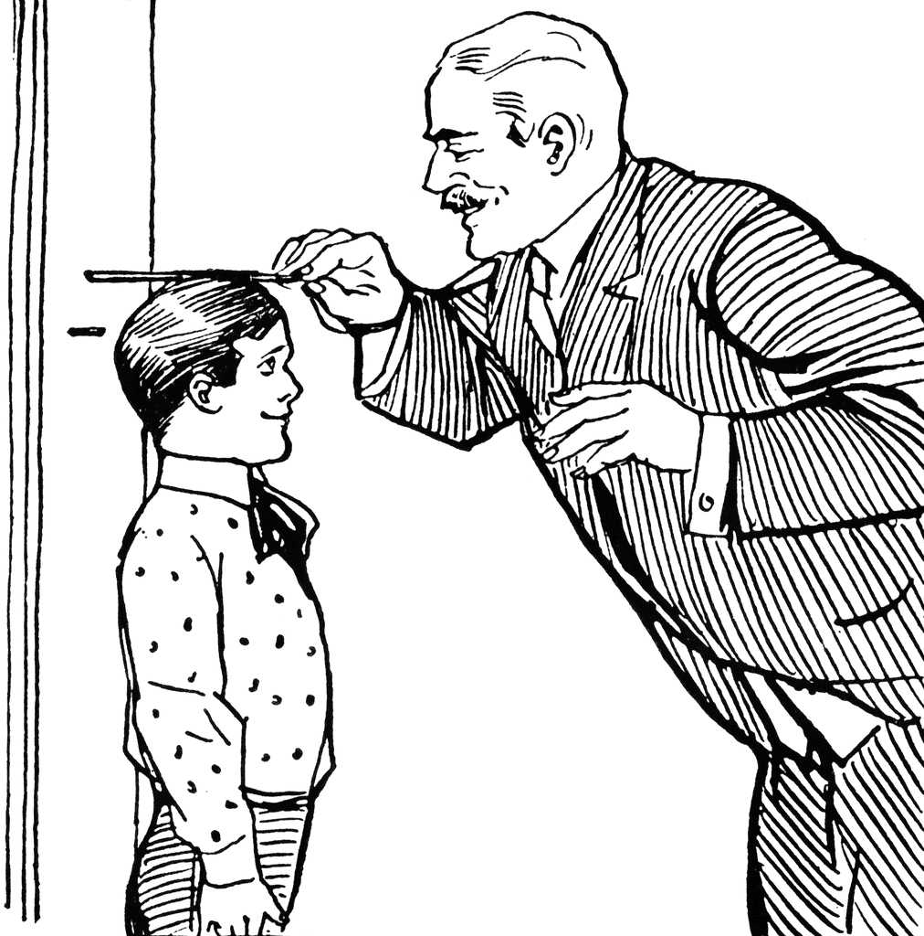
- Height
There several stations for measuring height, please measure your height once at three of them. At each station, remove your shoes. Stand at the station with your heels, head and back against the wall, neck erect. Have a partner identify your maximum height as in the picture:Record your measurements in centimeters!

- Weight
There are several scales, please weigh yourself once at three of them. Remove any materials that will augment your true weight. Record your measurements in kg!

- Digits
Measure the maximum length of your second and fourth digits on your right hand as shown in the figure below. To take the measurement, place your right hand face-down on the grid paper. Position your hand so that the lateral interdigital webbing is along the horizontal line, and the vertical line passes through your finger tip (note that this underestimates the true length of your fingers). Mark the line indicating the maximum length of each finger. Measure each digit three times. Record measurements in cm!

Measuring 2nd and 4th digits
Thumb side 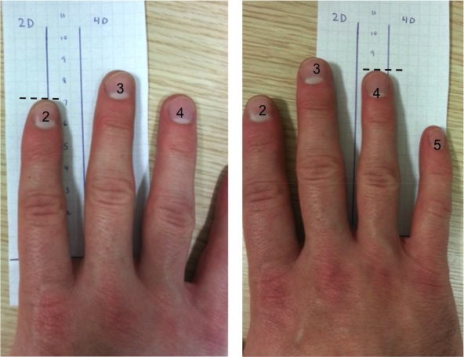

In-class discussion with small group
When you have collected and submitted your data, discuss the following questions in your small group.
- Based on the following figure, what social composition (‘breeding system’) would you hypothesize for humans based on sexual dimorphism? What male competition levels? Do you think our class will match these human values, and why or why not?
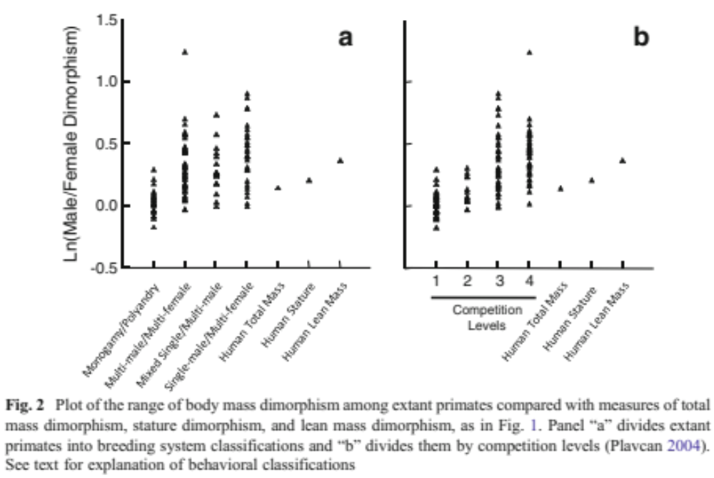

- Based on the following figure, what social composition would you hypothesize for humans based on sexual dimorphism? What male competition levels? Do you think our class will match these human values, and why or why not?
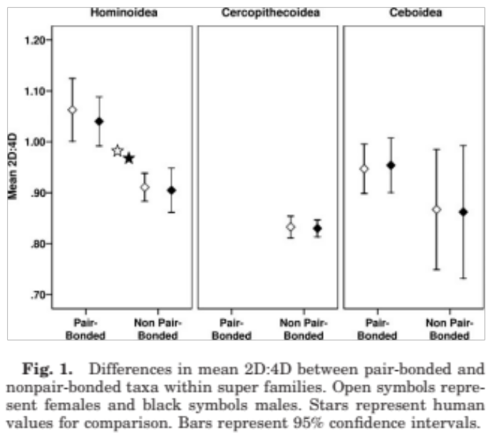
- Are human sexual dimorphism in both mass and 2D:4D consistent with one another? That is, do humans compare to other primates in the same way for both measures of dimorphism?
Lab report questions
- Briefly describe measurement error:
  - How do your measurements vary between instruments (e.g., between different height stations, scales)?
  - How much intraobserver error did you have for your digit measurements? Why do you think?
- For each variable (brain size, height, mass, 2D:4D ratio), is the difference between the sexes statistically ‘significant’ and how do you know?
  - What is the index of dimorphism for each?
- Are levels of sexual dimorphism consistent between each brain size, height, finger length, and body mass?
  - Compare and contrast dimorphism in these variables, and offer an explanation as to why they differ/are similar.
- Compare our observed classroom dimorphism with that reported for other humans and other primates (see in-class questions on previous page):
  - What does our class’s body weight sexual dimorphism suggest about social systems and male-male competition in our species?
  - What does 2D:4D suggest about social systems and male-male competition in our species?
  - Are primate-based predictions about our social system compatible between our mass and 2D:4D estimates?
    - If not, hypothesize reasons for this difference.

