Introduction
The brain imbues humans with our unique cognitive capabilities. The fossil record does not give us any actual brains, but we can at examine brain size, roughly measured as endocranial volume (ECV). Assuming our remarkable brain size at least partly underlies our intellect, we can ask how this evolved by look at brain size in different hominins over evolutionary time. You will address these issues by estimating brain size of different hominin specimens based on external cranial dimensions.

Measurement instructions
You will take up to three measurements on each specimen. Which measurements you take will depend on how well preserved the specimen is.

W (maximum width, M8): This is the maximum mediolateral width across the parietal bones (euryon-euryon). In many specimens it may be difficult to tell where exactly the parietal bones are, especially on the smaller-brained hominins whose cranial breadth is greatest across the temporal bones inferior to the parietal bones.

L (maximum cranial length, M1): This is the distance from the landmarks glabella and opisthocranion. Glabella is the anterior-most projecting point along the center of the brow, and opisthocranion is the furthest away from glabella at the center of the back of the cranium.

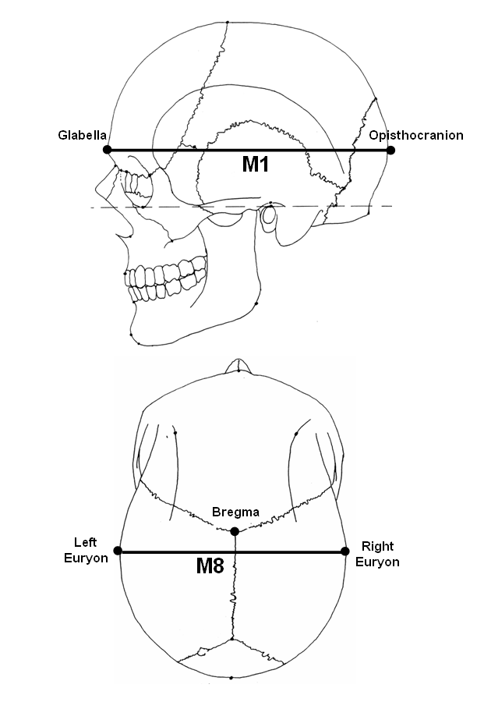

Lab report
Once you have entered your measurements into the datasheet, Excel will estimate the endocranial volume for each specimen based on the measurement and how it relates to ECV in each chimpanzees and humans.

Answer the following questions, using complete sentences, based on the cranial capacity estimates you have obtained.

- For specimens with both height and width, how do your estimates compare:
  - Based on both the ape and the human estimation models, do both height and width give roughly similar estimates? Why or why not?
  - Which model, ape or human, do you think might provide you with the best estimates for each specimen, and why?
- Using Excel, create two scatterplots with estimated ECV on the Y axis and Date (geological age) on the X axis. One plot should include brain size estimated by the ape model, and the other should use the human model. For specimens with two estimates from cranial width and length, pick just one estimate for your graphs (or use their average).
  - Include these plots in your report!
- Answer the following questions based on the plots:
  - How do Australopithecus boisei and Homo compare in terms of brain size? Do you have the same interpretation of Australopithecus-Homo differences based on each estimation model? Explain.
  - Describe brain size change over evolutionary time in each species. Do you see the same patterns of change based on each estimation model? Explain.
- Here is a table showing ECV for each specimen estimated directly from measuring the endocranium. Answer the following questions comparing your cranial estimates with these more direct estimates of ECV for each specimen.
Specimen | Actual ECV
KNM ER 406 | 510
OH 5 | 591
WT 17000 | 410
ER 42700 | 691
WT 15000 | 880
ES 11693 | 1350
ER 3733 | 848
ER 1470 | 750
ER 3883 | 803
ER 1813 | 510

  - How well does each model predict the actual cranial capacities of each fossil? Explain.
  - Does the ape model work better for some? Human better for others? Are there any patterns in terms of the goodness of fit of the models? Explain.
  - Hypothesize a reason why different fossils might fit either model better.

